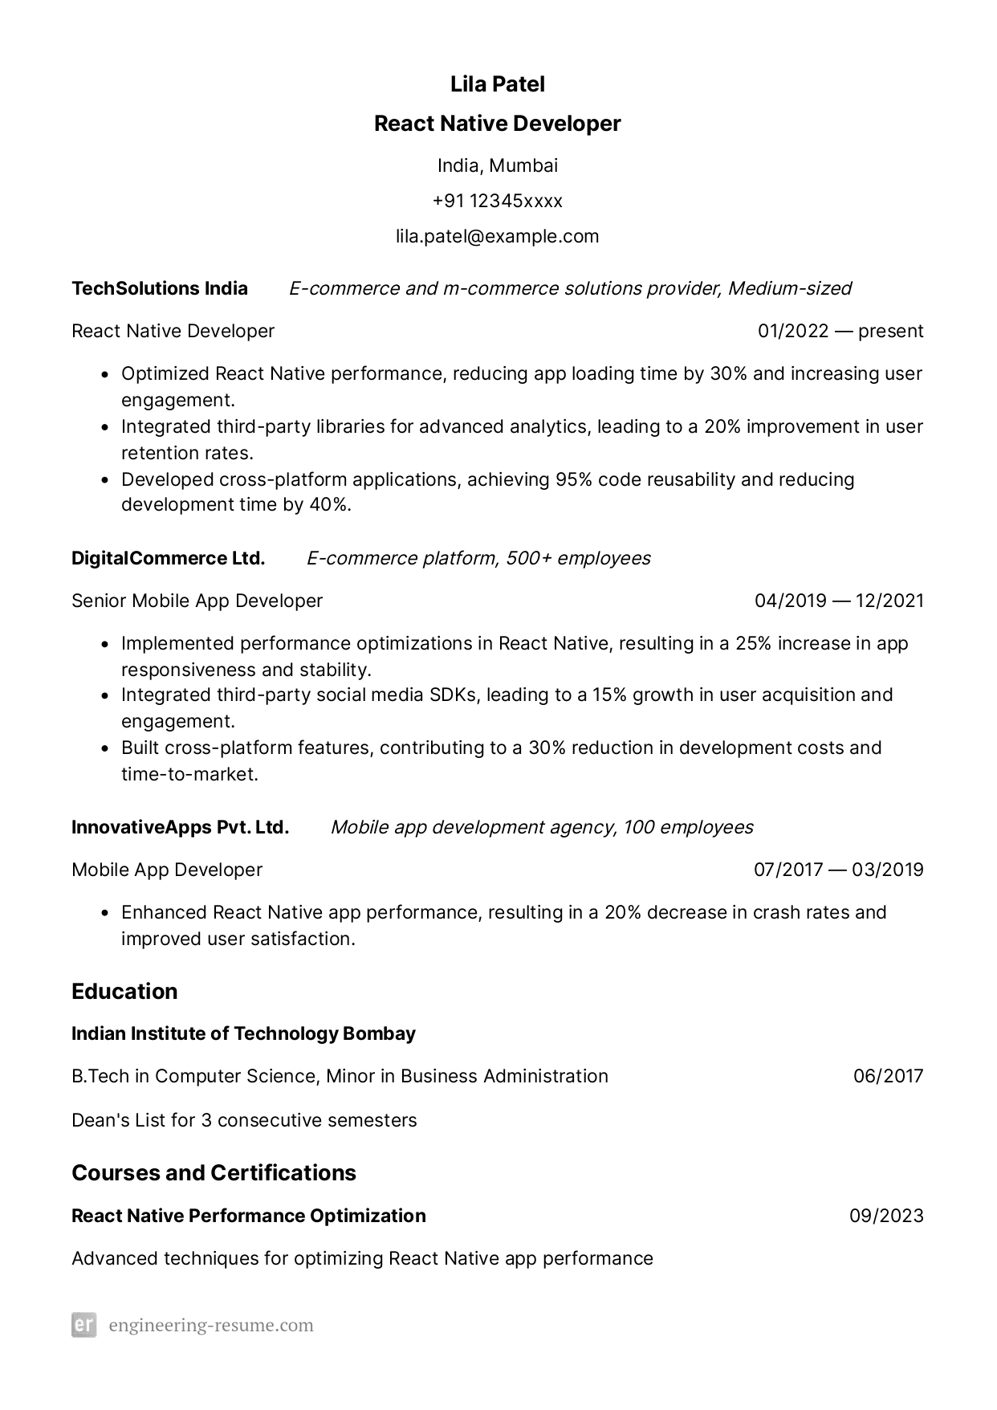
TechSolutions India
React Native Developer
Lila Patel
React Native Developer
India, Mumbai
+91 12345xxxx lila.patel@example.com
E-commerce and m-commerce solutions provider, Medium-sized 01/2022 - present
• Optimized React Native performance, reducing app loading time by 30% and increasing user engagement.
• Integrated third-party libraries for advanced analytics, leading to a 20% improvement in user retention rates.
•
Developed cross-platform applications, achieving 95% code reusability and reducing development time by 40%.
DigitalCommerce Ltd.
E-commerce platform, 500+ employees
Senior Mobile App Developer
·
·
04/2019 - 12/2021
Implemented performance optimizations in React Native, resulting in a 25% increase in app responsiveness and stability.
Integrated third-party social media SDKs, leading to a 15% growth in user acquisition and engagement.
• Built cross-platform features, contributing to a 30% reduction in development costs and
time-to-market.
InnovativeApps Pvt. Ltd. Mobile app development agency, 100 employees
Mobile App Developer
07/2017 03/2019
• Enhanced React Native app performance, resulting in a 20% decrease in crash rates and improved user satisfaction.
Education
Indian Institute of Technology Bombay
B.Tech in Computer Science, Minor in Business Administration
06/2017
Dean's List for 3 consecutive semesters
Courses and Certifications
React Native Performance Optimization
09/2023
Advanced techniques for optimizing React Native app performance
er engineering-resume.com

